Spot Light

📘 Definition
# Source: AI Source: Provided by: [Data Path: Persons Table -> ID Column: 1, Name_En Column: Motasem Essam] -> From: [ChatGPT] on [5/2/2026]
A Spot Light is a type of light source in computer graphics that emits light in a specific direction within a cone-shaped area, like a flashlight or stage spotlight.

🔦 How Spot Light works
# Source: AI Source: Provided by: [Data Path: Persons Table -> ID Column: 1, Name_En Column: Motasem Essam] -> From: [ChatGPT] on [5/2/2026]
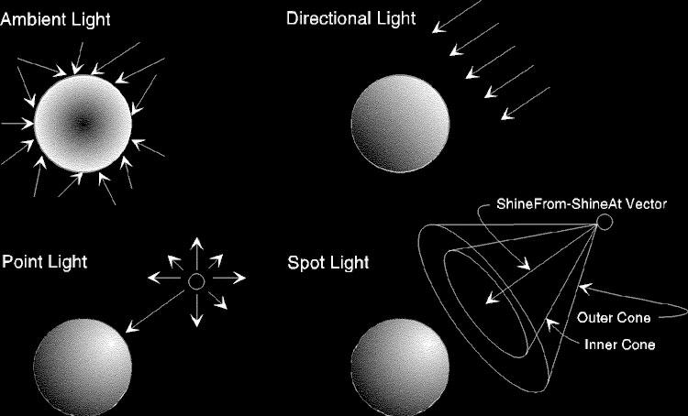
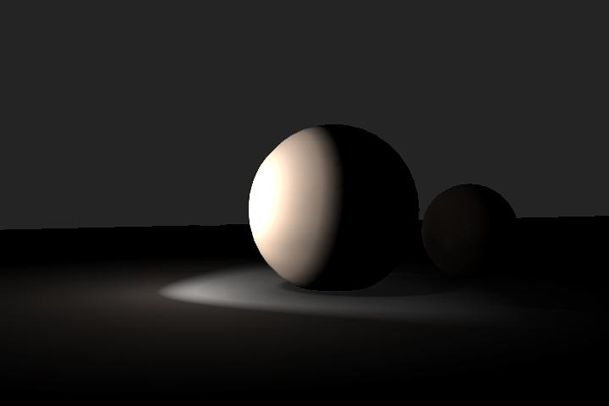

- Light starts from a single point
- It shines in one direction only
- Forms a cone (narrow or wide)
- Brightest at the center, fades toward the edges

🧠 Simple example
# Source: AI Source: Provided by: [Data Path: Persons Table -> ID Column: 1, Name_En Column: Motasem Essam] -> From: [ChatGPT] on [5/2/2026]
Think of:
- 🔦 A flashlight
- 🎭 A stage spotlight on a performer
Only a specific area is lit, while the rest stays dark.

🎮 Where Spot Light is used
# Source: AI Source: Provided by: [Data Path: Persons Table -> ID Column: 1, Name_En Column: Motasem Essam] -> From: [ChatGPT] on [5/2/2026]
- 🎮 Video games (torches, headlights)
- 🎬 Movies and animations (focused lighting)
- 🎭 Stage and theater lighting
- 🧑‍💻 UI highlights and focus effects

⚙️ Key features
# Source: AI Source: Provided by: [Data Path: Persons Table -> ID Column: 1, Name_En Column: Motasem Essam] -> From: [ChatGPT] on [5/2/2026]
- 📍 Has a position and direction
- 🔺 Light is limited to a cone shape
- 🎯 Can focus on a specific object or area
- 🌑 Creates strong, focused shadows

🚀 In short:
# Source: AI Source: Provided by: [Data Path: Persons Table -> ID Column: 1, Name_En Column: Motasem Essam] -> From: [ChatGPT] on [5/2/2026]
Spot Light = a focused light that shines in one direction in a cone shape, like a flashlight or stage light.

